# IWI game slot machine Texture pipeline v2.0

1.export the textures from the flash which grabed from p4;

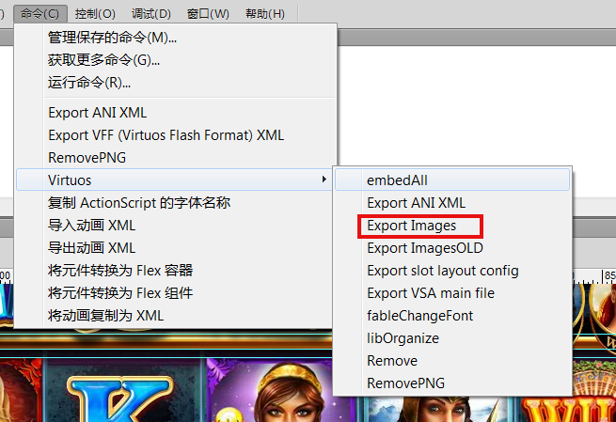

**To implement it ,first you should set the Export Images.jsfl to the address like:

C:\Users\username\AppData\Local\Adobe\Flash CS6\zh_CN\Configuration\Commands\Virtuos

p4: 10.0.0.109:1666

//C10159P13001/GamesysJackpotSlots/ArtAssets/ForNew/

2.package the textures:

-setup the TexturePacker-3.0.3.

tide up the images which exported from the flash to folders like : "ui_elements." according to the usage of the images in the folders.

**please do not divide the whole animation images to 2 different folders. if so you should do some extra work but it's still ok.

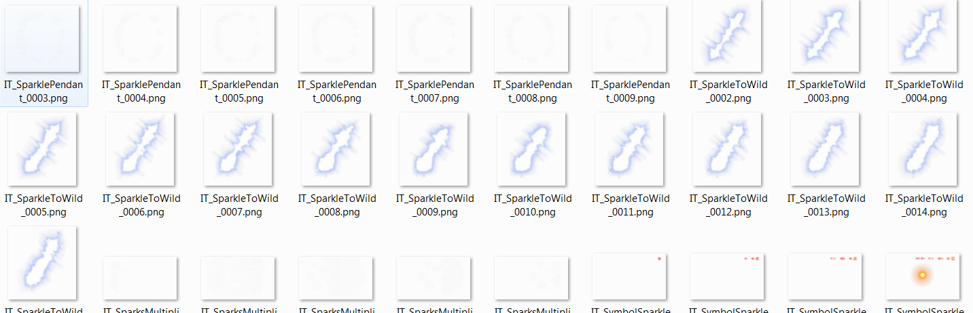

eg:

**public** **var** IT_SymbolSparkle:Vector.<ICompatibleTexture>;

**private** **var** _IT_SymbolSparkle1:Vector.<ICompatibleTexture>;

**private** **var** _IT_SymbolSparkle2:Vector.<ICompatibleTexture>;

**public** **function** **set** IT_SymbolSparkle2(value:Vector.<ICompatibleTexture>):**void**

{

**for**(**var** i:* **in** value)

{

IT_SymbolSparkle.push(value[i]);

}

}

**public** **function** **set** IT_SymbolSparkle1(value:Vector.<ICompatibleTexture>):**void**

{

**if**(IT_SymbolSparkle==**null**)

{

IT_SymbolSparkle= **new** Vector.<ICompatibleTexture>();

}

**for**(**var** i:* **in** value)

{

IT_SymbolSparkle.push(value[i]);

}

}

in the _manifest:

<skinElement componentType="ISlotGameView" skinPropertyName="IT_SymbolSparkle1" atlas="Particle1" isButton="false" isPrefix="true">IT_SymbolSparkle</skinElement>

<skinElement componentType="ISlotGameView" skinPropertyName="IT_SymbolSparkle2" atlas="Particle2" isButton="false" isPrefix="true">IT_SymbolSparkle</skinElement>

-the folder structure should be like:

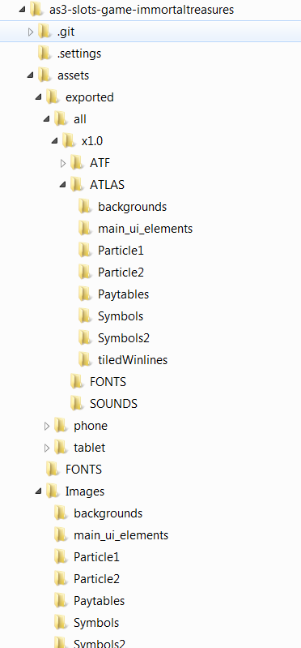

the "Images" folder should contain all the images that exported from flash and make sure you have put them into typical folders:eg:

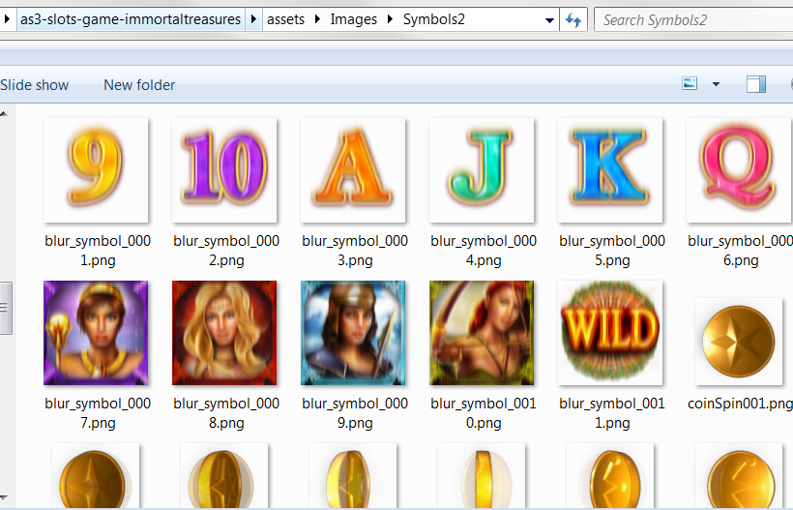

-make tps:

drag the images or the folder you want to package into Texturepacker:

make sure you have choosen the starling format, png

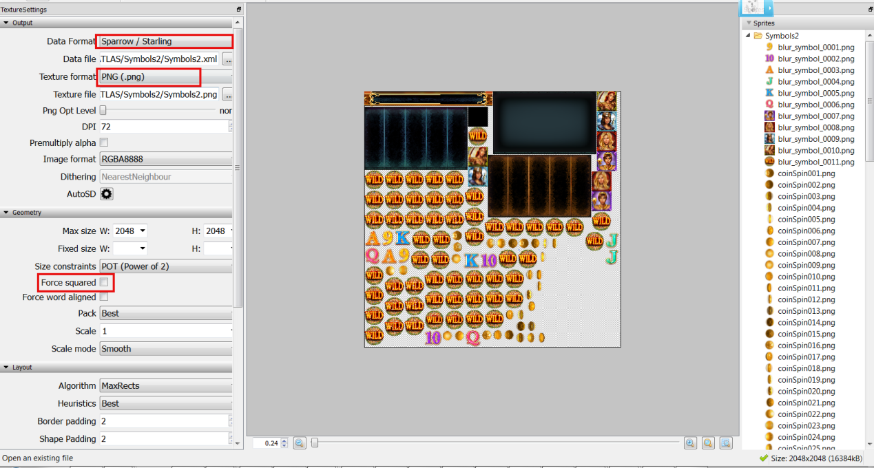

and it's better if you choose the Trim mode.

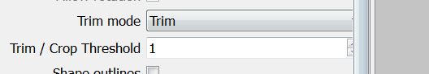

and then, save and publish to the ATLAS folder

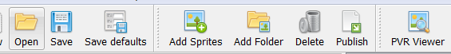

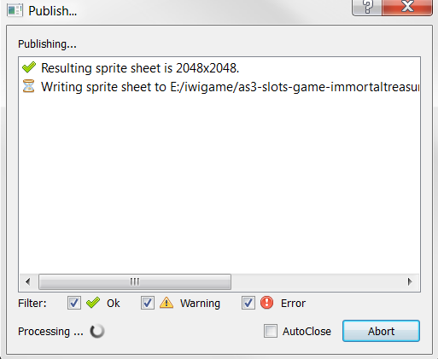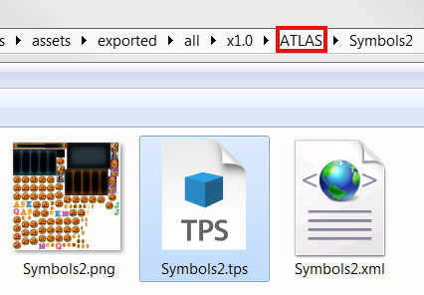

### -make the tiled winline

you should have the winline images exported from the flash.

set up the IWISlotsGameTool.air, if you can not open it download and install the air runtime firstly.

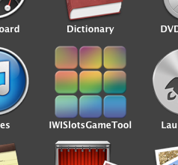

drag the winline folder to

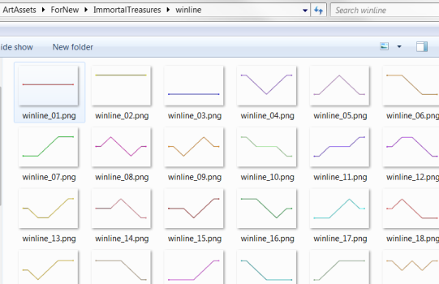 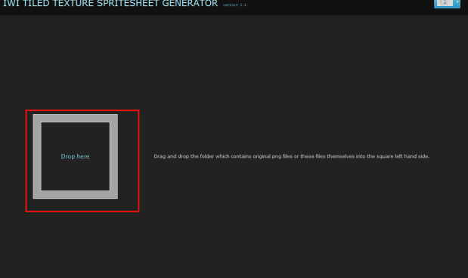

force set squared texture. and choose the exported folder to the address like:

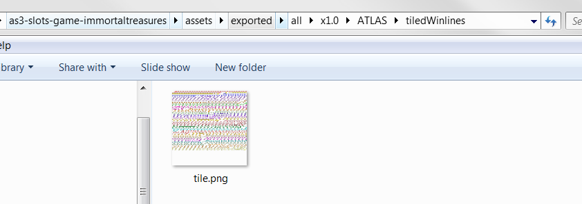

and click generate , if you failed please choose larger size.

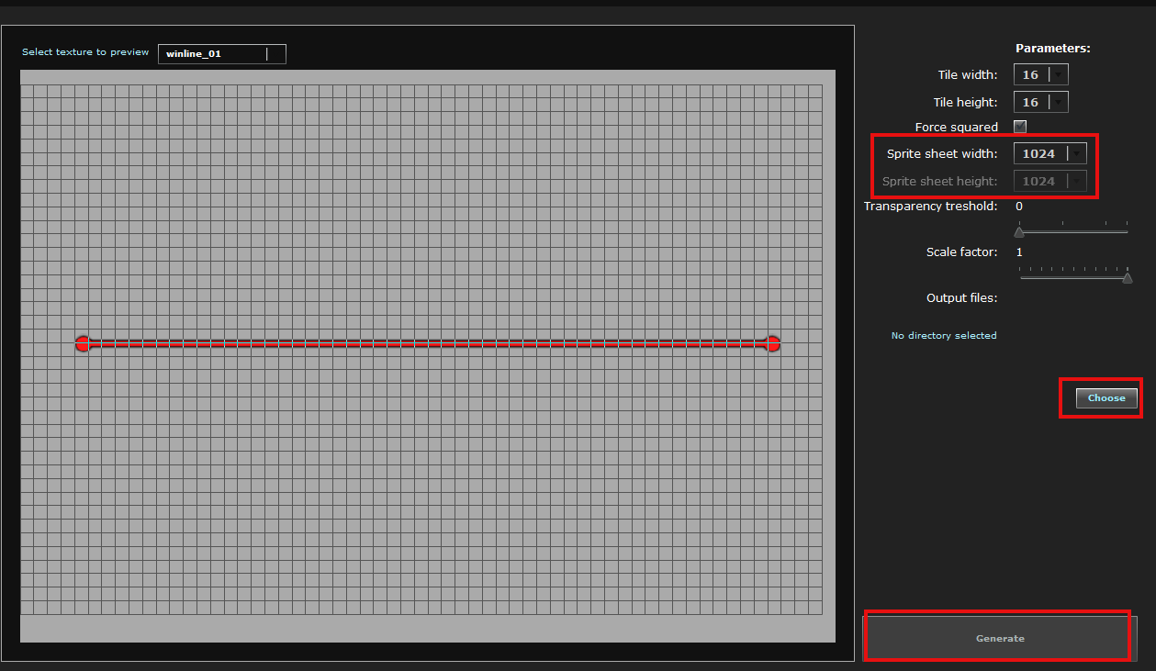

-create the atf files:

-copy png2atf to somewhere in your PC and set the envirementPath to point it.

-copy and Extract the apache-ant-1.9.0 to your PC and set the envirementPath to point the .( \bin)

try and test

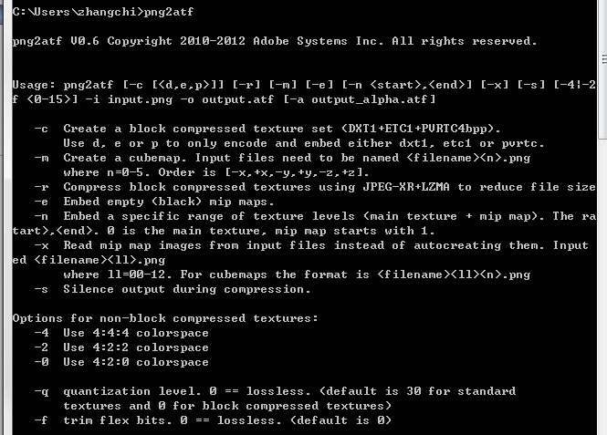

** create the assets/embedded/starling first in your project before make the atf

### -DownLoad and run ant script to make ATF(please reference the Buildingslotswiththebuildtoolsproject.pdf)

if every thing is ok, you can get the 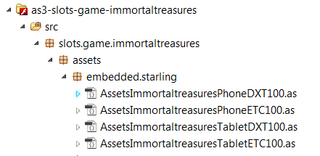

and all the atf textures.

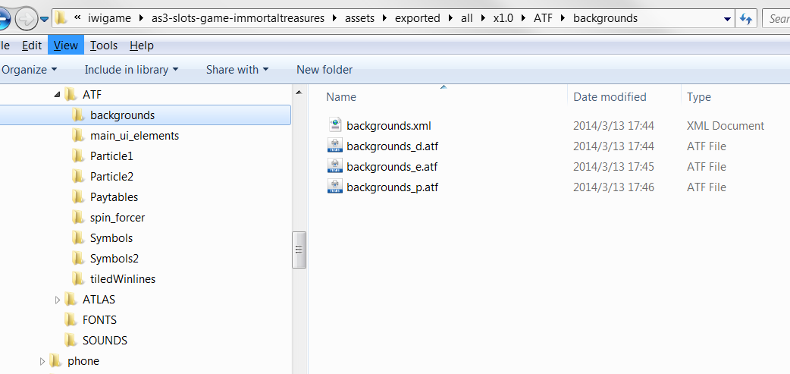

### Making the blur symbols

create a folder in Assets/PNG_ORIGINAL RENAMED first.

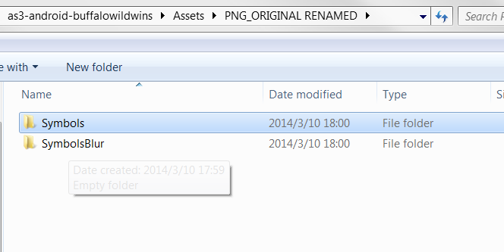

Steps:

(not necessity)

- Install Cygwin 32-bit (full install) if not already installed, from:

<http://www.cygwin.com/install.html>

- Install the 'Portable Win32 static' version on ImageMagick for Windows (ImageMagick-6.8.6-7-Q16-x86-windows.zip) from:

<http://www.imagemagick.org/script/binary-releases.php#windows>

                - Unzip to a suitable folder, e.g.:

                                - D:\work\gamesys\tools\ImageMagick-6.8.6-7

                - When installed copy **convert.exe** from the root folder to **bin\** (you'll need to create the bin folder)

- Install JDK 7 from:

<http://www.oracle.com/technetwork/java/javase/downloads/index.html>

                - Install to **C:\Program Files (x86)\Java** (**Note** - Not the default install directory)

                - When installed copy **tools.jar** from **Java\lib**  to **Java\jre\lib**

- Download Apache Ant, from:

<http://ant.apache.org/bindownload.cgi>

                -  [apache-ant-1.9.2-bin.zip](http://apache.fayea.com/apache-mirror/ant/binaries/apache-ant-1.9.2-bin.zip)

                - Unzip to a suitable folder, e.g.:

                                - D:\work\gamesys\tools\apache-ant-1.9.2

- Modify user.properties

                - Change folder to the slot's scripts folder in Cygwin, e.g.:

                                - cd d:

                                - cd work/gamesys/as3-slots-game-doublebubble/scripts   (use your location, it will be different!)

                - Make your own copy: **cp user.properties.template user.properties**

                - Edit **user.properties**

              ATF_UTILS=/cygdrive/d/work/gamesys/as3-slots-game-doublebubble/scripts/tools/  (<--- Change this to your slot's location)

              IMAGE_MAGICK=D:\\work\\gamesys\\tools\\ImageMagick-6.8.6-7  (<--- Change this to where you unzipped ImageMagick to)

- Edit **~/.bashrc**

                - At the end of the file add:

              export ANT_HOME=/cygdrive/c/apache-ant-1.9.3

              export PATH=$ANT_HOME/bin:$PATH

                - Restart Cygwin or type:

                                source ~/.bashrc

                - Check if Ant is installed and working or type:

                                ant -version

- Change folder to <slot folder>/scripts, and run Blur Symbols Ant Scripts:

                - ant blur_symbols_100

if you suffered some issue just try to put the convert.exe to bin folder.

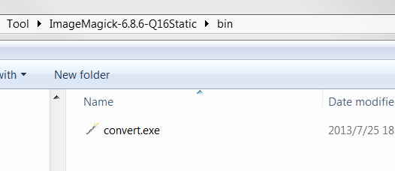

if everything goes ok you can get the blur symbols now

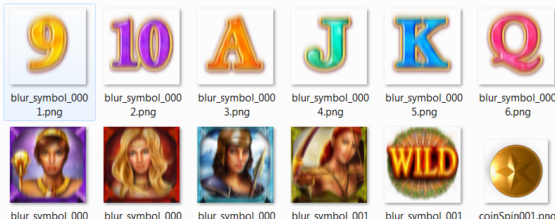

### set the backgrounds images

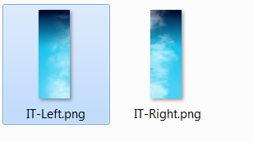

package them into some spritesheet .

set them into the _manifest

<backgrounds>

<background atlas="backgrounds">IT-Left</background>

<background atlas="backgrounds">IT-Right</background>

</backgrounds>

### If you have the atfs and the embedded class, you can start to do coding.

making the mainfest.xml, you can type it or you can also make it by SlotsXMLParser - v***.exe

which is quite easy job for you.

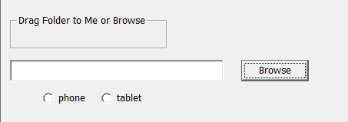

you can git clone the reference from client side :

TOOLS:

<https://github.com/iwi-games/as3-slots-buildtools.git>

<https://github.com/iwi-games/as3-slots-harness.git>

LIBS:

<https://github.com/iwi-games/as3-slots-game-core.git>

<https://github.com/iwi-games/as3-shared-view-abstraction.git>

<https://github.com/iwi-games/as3-slots-game-components.git>

DOUBLEBUBBLE:

<https://github.com/iwi-games/as3-slots-game-doublebubble.git>